
Module 8: Recognition and Control of Noma Time: 90 minutes

Learning Objective:
Control noma in your geographical area by:
- Building awareness of the disease in the community
- Identifying and treating affected individuals
- Promoting prevention strategies

Additional Materials Needed:
- Flipchart and markers
- PowerPoint presentation
- PowerPoint handout
- Annex handouts
- AEIPI module

Brainstorming Session and Discussion:

Questions to Consider:

- When you think of promoting oral health, do you even consider that you might be saving a child’s life?

- Do you know of any oral diseases that are life-threatening?

- Have any of you heard of a disease known as noma? Have you seen it? Would you be able to recognize early warning signs of the disease?

Begin PowerPoint presentation.

Slide 1 | 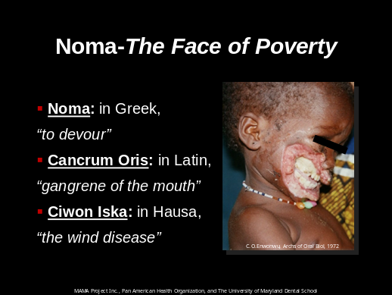 | Noma, also called Cancrum Oris  If you have never heard of noma, our hope is that after this workshop, you’ll never forget it. Noma is one of the most tragic and disfiguring infectious diseases worldwide. It marks its victims with a facial deformity that is impossible to disregard and targets children who live in conditions of extreme poverty. Thus, it makes sense that noma is often referred to as the “Face of Poverty”. It has many names whose meanings emphasize the degree of the deformity and its rapid development. (Explain names on slide)
Slide 2 | 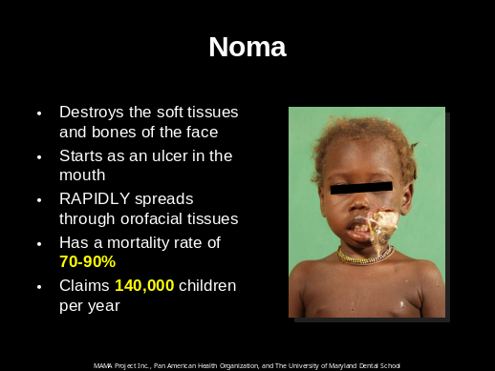 | What is Noma?  Noma is an infectious disease that destroys the soft tissues and bones of the face. Initially, the lesion starts as an ulcer in the mouth. But if left untreated, the ulcer RAPIDLY spreads through orofacial tissues and often perforates the lip or cheek. Approximately, 70-90% of individuals inflicted by noma die due to complications such as pneumonia, sepsis, and/or diarrhea. Across the world, an estimated 140,000 people die per year, primarily in Sub-Saharan Africa.
Slide 3 | 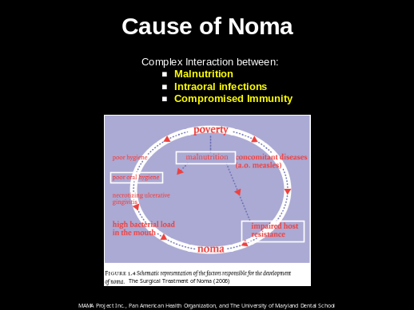 | Cause of Noma  Unlike many other deadly childhood diseases such as measles, noma is not caused by a single pathogen (germ). Instead many different bacteria acting together in a vulnerable child seize the opportunity to overcome the child’s weakened immune defense system. Studies have found that noma is the result of 3 crucial factors: malnutrition, intraoral infections, and compromised immunity. Children living in extreme poverty often suffer from all three of these conditions and are at high risk of developing the disease.
Slide 4 | 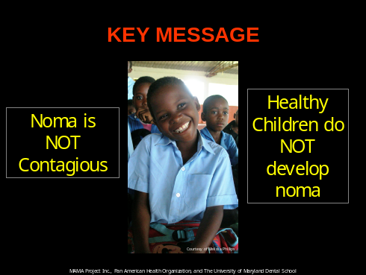 | Key Message  Healthy children who are well nourished and do not live in poverty are NOT at risk of developing noma, even if they come in contact with the same causal bacteria.  Noma is not a contagious disease!
Slide 5  Slide 6 | 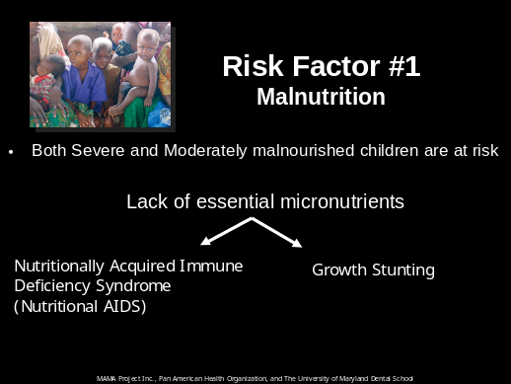 | Risk Factors  Noma is not a tropical disease, nor is it a disease of developing countries. Noma is a disease of poverty. It primarily infects children ages 1-6 who live in areas that are socioeconomically deprived. Pervasive poverty is the key risk factor that gives rise to four other primary risk factors:  - severe malnutrition  - poor hygiene and sanitation practices  - limited access to good healthcare  - recent severe infections such as measles or malaria, that further knock down a child’s already weakened immune system  We will now discuss each of these risk factors in further detail.  Risk Factor #1= Malnutrition  Undernourished children are prone to suffer from serious infections. All children need the proper amounts of quality foods that include enough carbohydrates, fats, proteins, vitamins and minerals, beginning even before birth.  Unfortunately, many children begin life with a weakened immune system because their mother was malnourished during pregnancy. Children deprived of these nutrients during early development are at risk of acquiring Nutritionally Acquired Immune Deficiency Syndrome which increases susceptibility to infections. Nutritionally Acquired Immune Deficiency Syndrome is similar to HIV Acquired Immune Deficiency Syndrome in that both allow opportunistic infections to flourish in their victims.  Surprisingly, many of these children may not look very sick, but a clue to their micronutrient deficiency and “Hidden Hunger” is the slowing of growth early in life. Growth stunting is a marker for a child at risk of developing noma.
Slide 7 | 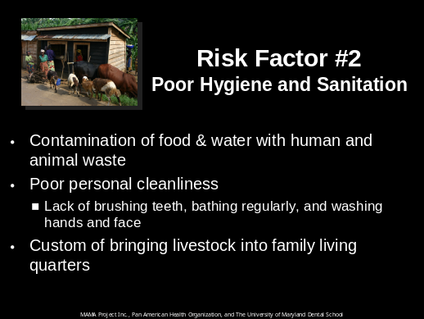 | Risk Factor #2 Poor Hygiene and Sanitation  (Read Slide)
Slide 8 |  | Risk Factor #3 Recent Immuno-suppressive Infection  (Read Slide)  These diseases severely weaken the immune system, making it difficult for the body to fight against bacteria that are normally not strong enough to cause disease. Children who present with noma often have one of these infections or have suffered from one of them in their recent past.
Slide 9 | 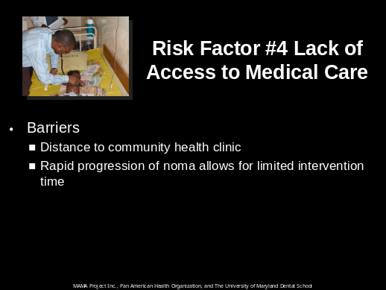 | Risk Factor #4 Lack of Access to Medical Care  Because many children infected by noma live in rural communities far away from a health clinic, they are not able to receive the appropriate medical care.  In addition, since noma can quickly progress from a small oral ulcer to a large area of facial gangrene in a span of weeks, there is very little time available to medically intervene.
Slide 10 | 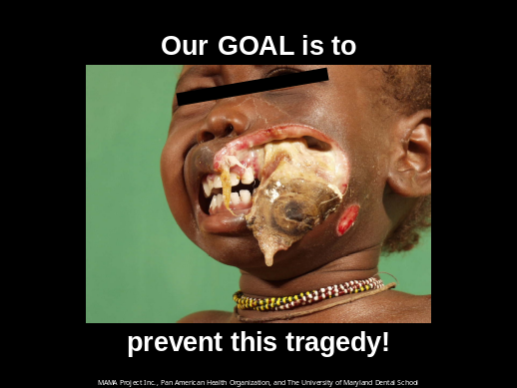
Slide 11 | 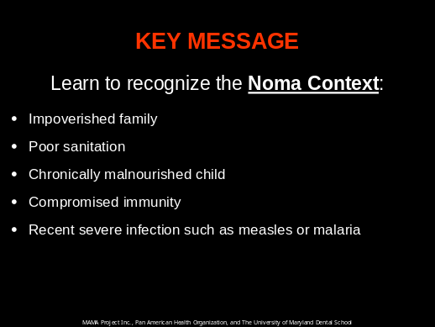 | Recognize the Noma Context  Remember, noma is not seen among healthy children. Instead, it is most commonly identified in children who are malnourished, immune deficient, and have recently suffered from an infection.  (Read Slide)  Whenever you encounter a child in this context, a thorough oral screening should be preformed to look for early signs of noma.
Slide 12 | 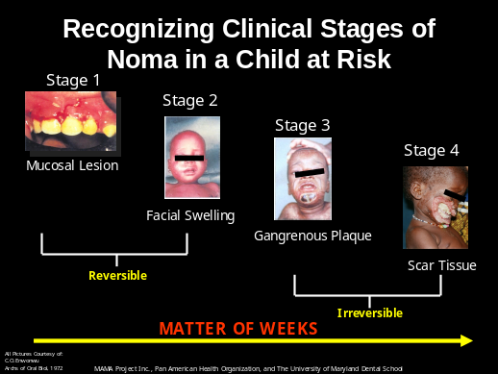 | Clinical Stages of Noma  There are 4 clinical stages of noma. It is very important that we learn to recognize the early signs of disease. If noma is not identified and treated in the early and advancing stages, gangrene can permanently destroy the structures of the face.  (Explain Slide)
Slide 13  Slide 14 | 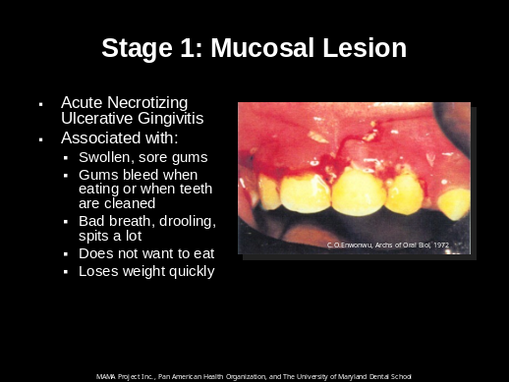  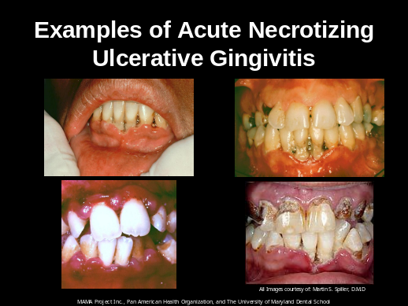 | Stage 1: Mucosal Lesion  Noma often starts with gum disease. Gums that are weak from poor nutrition are not able to resist the infection. Mild gum disease can progress to Acute Necrotizing Ulcerative Gingivitis (ANUG), which is an intra-oral lesion that has the potential to become an entry point for noma to advance into the gangrenous phase. ANUG is often accompanied by the following symptoms…(read slide) Suspect noma in children with mouth sores or ANUG, ESPECIALLY if malnourished with recent illness such as measles or malaria  Examples of Acute Necrotizing Ulcerative Gingivitis (ANUG)  ANUG is also commonly referred to as “Trench mouth”. This is a painful bacterial infection that involves inflammation (swelling) and ulcers in the gums.
Slide 15 | 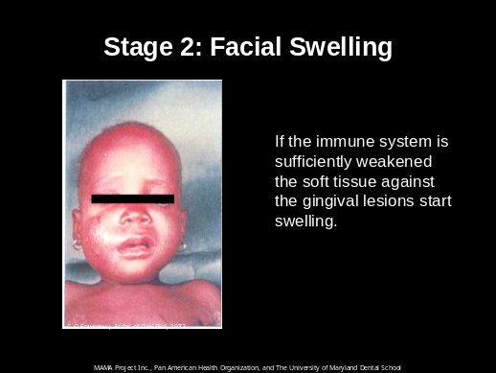 | Stage 2: Facial Swelling  Stage 2 is characterized by the swelling of the cheek, chin, or lips. The swelling is often accompanied with fever, pain, drooling, and foul breath.  Antibiotics can still save this child’s face and life.
Slide 16 | 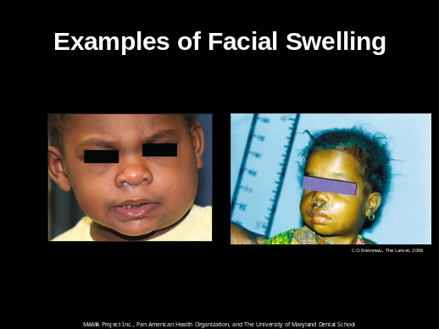 | Examples of Facial Swelling  Often times, the swelling is unilateral, meaning the swelling is on one side of the face
Slide 17 | 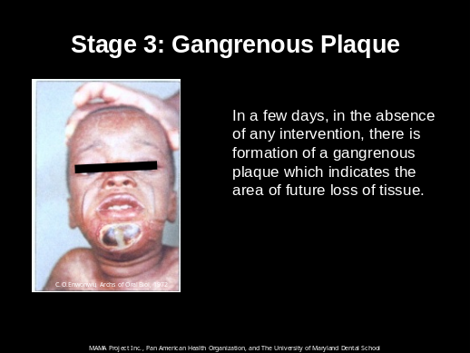 | Stage 3: Gangrenous Plaque  Noma does not stop in the soft tissues of the face. It destroys flesh and bone. During this stage look for:  - Tight skin with dark red swelling  - Black spot (gangrene/necrosis) on the face breaks open, revealing the extent of the permanent tissue loss  - A clear line that separates dead tissue from healthy tissue  - Loose teeth  - Dead pieces of bone around the teeth  Noma breaks through to the surface of the face, usually the cheek, but it can also involve the eyes, lips, and nose.
Slide 18 | 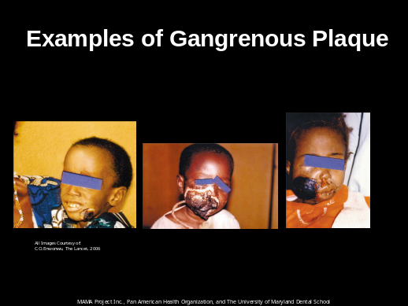 | Examples of Gangrenous Plaque
Slide 19 | 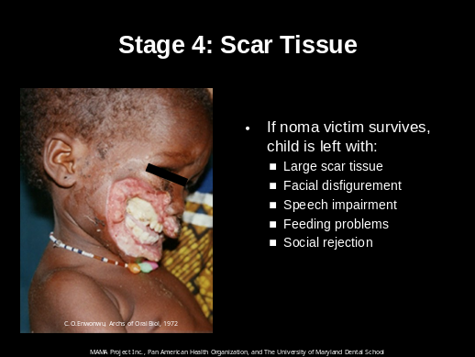 | Stage 4: Scar Tissue  Upon healing, large amounts of scar tissue allow for minimal opening of the mouth. Functional as well as aesthetic sequelae (long-term effects) are extremely distressing. In fact, noma may even be perceived as a curse in some communities.
Slide 20 | 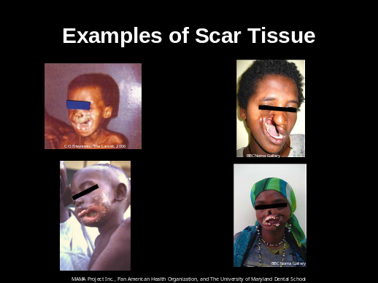 | Examples of Scar Tissue
Slide 21 | 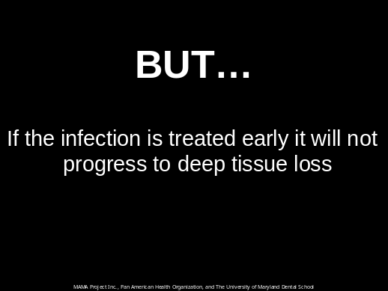 | Noma Treatment  The good news is that if the oral infection is treated properly during the early stages of the disease, we can prevent it from progressing to full blown noma! In order to limit the extent of the damage, you must start treatment for noma as soon as it is recognized. The longer the delay, the lower the survival rate, and the worse the physical and psychological trauma will be for the child.
Slide 22 | 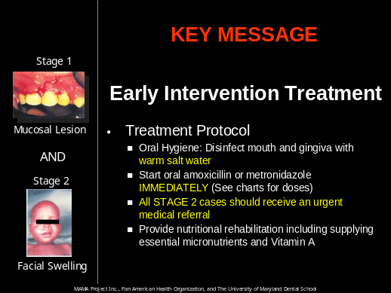 | Key Message: Early Intervention Treatment  - Clean Mouth  - Administer Antibiotics  - Refer Stage 2 cases IMMEDIATELY
Slide 23 | 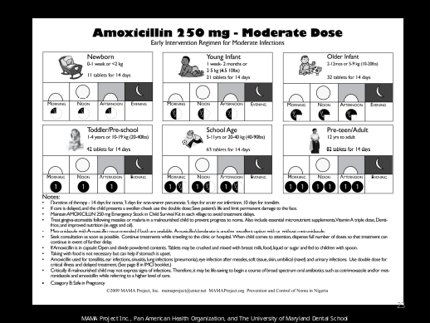 | Antibiotics: Amoxicillin-Moderate Dose  Educating parents and community leaders on how to use antibiotics EARLY in noma cases can save lives. Illiteracy is a barrier to proper use. Low literacy aids, like the dosage chart on this slide, can help ensure patient compliance.  Amoxicillin is a safe oral antibiotic that is effective against most common bacteria encountered in the community. This chart gives doses appropriate for moderate infections.
Slide 24 | 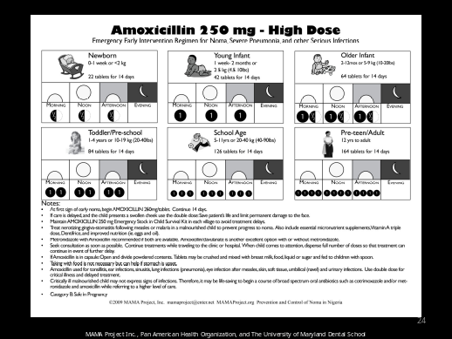 | Antibiotics: Amoxicillin-High Dose  This chart gives recommendations appropriate for severe infections, including noma.
Slide 25 | 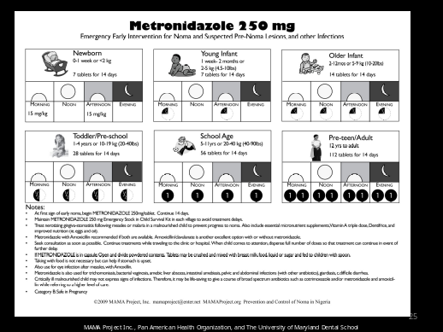 | Antibiotics: Metronidazole-Moderate Dose  Metronidazole and/or amoxicillin together or separately are effective in stopping early noma.
Slide 26 | 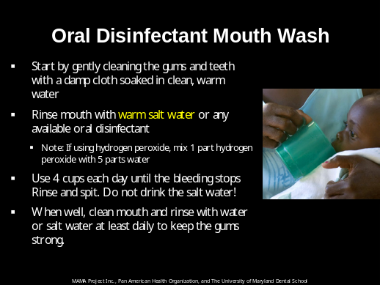 | Oral Disinfectant Mouth Wash  When you recognize a child who may have noma, it is important to first disinfect his/her mouth.  (Read Slide)  Salt water rinses (1/2 teaspoon of salt in 1 cup of water) may soothe sore gums. Hydrogen peroxide, used to rinse the gums, is often recommended to remove dead or dying gum tissue.
Slide 27 | 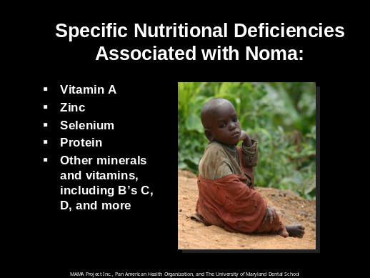 | Important Vitamins and Minerals  Children with noma have deficient levels of the following vitamins and minerals. Vitamin A is especially important because it boosts immunity and speeds healing. Nutritional therapy should include a full complement of multiple vitamins and minerals as well as nutritious food.
Slide 28 | 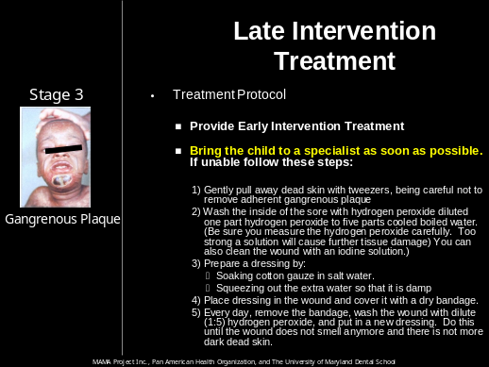 | Stage 3: Late Intervention Treatment Protocol  (Read Slide)
Slide 29 | 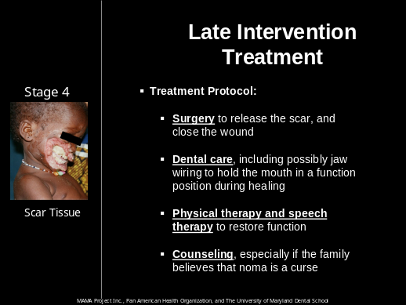 | Stage 4: Late Intervention Treatment Protocol  (Read Slide)
Slide 30 | 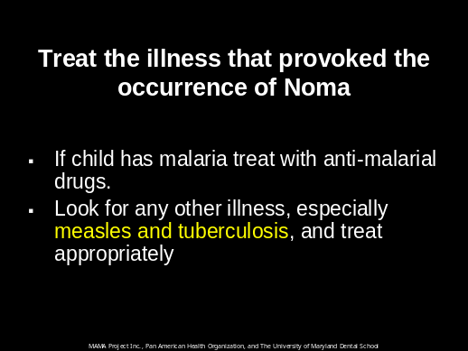 | Treat the Underlying Infection  Remember that noma is often (but not always) preceded by a disease that severely weakens the immune system. It is important to not only treat the immediate symptoms of noma, but also the underlying infection that may have set in motion the development of noma.
Slide 31 | 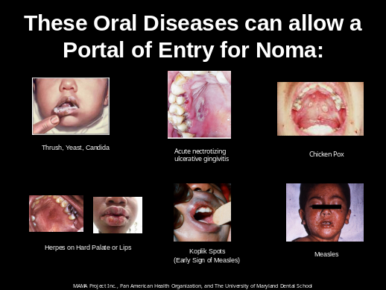 | Oral Disease Allow a Portal of Entry  Any oral disease that disrupts the oral mucosa can be a noma precursor in a child at risk.
Slide 32 | 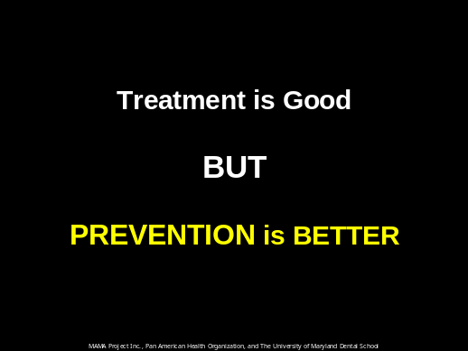
Slide 33 | 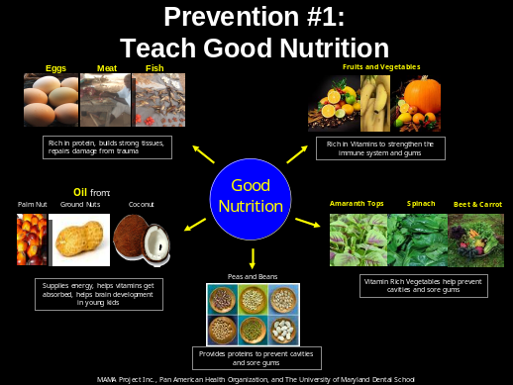 | Prevention #1: Teach Good Nutrition  Undernutrition contributes to more than  1 in 3 child deaths¹. As mentioned before, malnutrition is one of the primary risk factors of noma. Teaching good nutritional customs that are sustainable with the resources available in the community is essential.  (Explain Slide)  ¹World Health Organization. Countdown to 2015 Decade Report
Slide 34 | 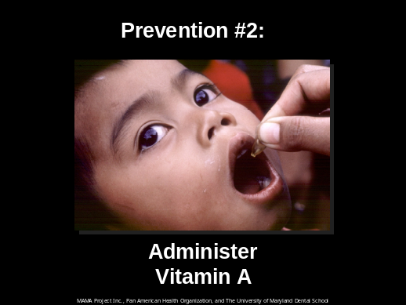 | Prevention #2: Administer Vitamin A  One of the highest yield public health prevention interventions that can be preformed in communities with noma is to administer vitamin A to all children.
Slide 35 |  | Focus on Vitamin A  (Read Slide)
Slide 36 | 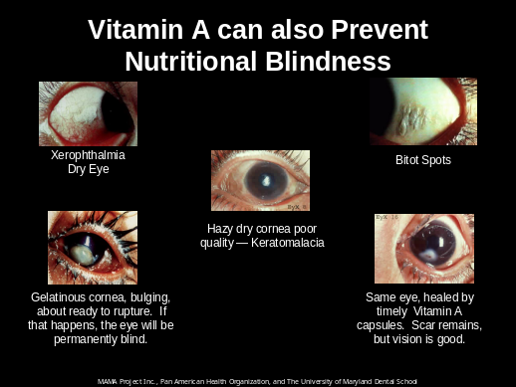 | Vitamin A Prevents Nutritional Blindness  Vitamin A not only promotes and maintains healthy teeth, skeletal and soft tissue, mucous membranes, and skin, but ALSO prevents Nutritional Blindness.
Slide 37 | 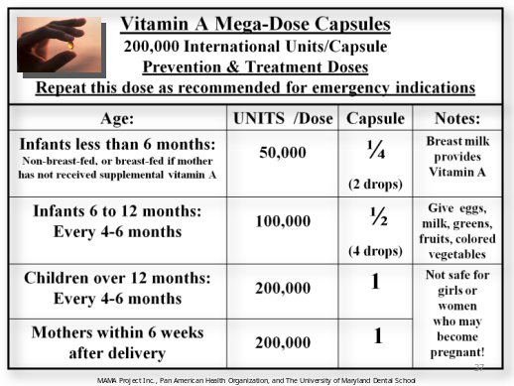 | Administration of Vitamin A Mega-Dose Capsules
Slide 38 |  | Recommendations for Vitamin A Administration  Note: This dosage regimen may be too aggressive compared to recommendations made by your Ministry of Health. Vitamin A should be given to all target groups according to the dosage schedules endorsed by your Ministry of Health.
Slide 39 |  | Prevention #3: Micronutrients
Slide 40 | 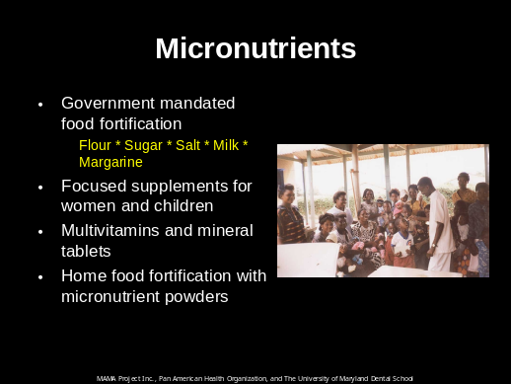 | Micronutrients  Often these foods are fortified with the following micronutrients:  Flour: Iron and Vitamin B  Sugar: Vitamin A  Salt: Iodine and sometimes Fluoride  Milk and Margarine: Vitamin D & A  Iron supplements should be provided for children. Folate and Iron supplements should be provided for prenatal women.
Slide 41 | 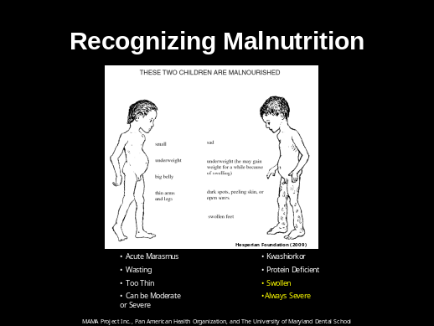 | Recognizing Malnutrition  (Explain distinguishing characteristics of each child).
Slide 42 | 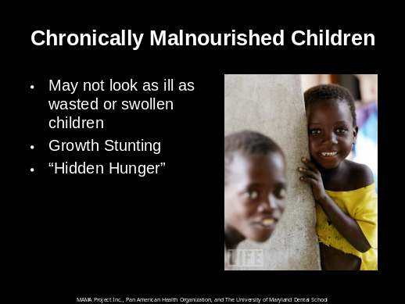 | Chronically Malnourished Children  In communities where malnutrition is a public health problem and food insecurity is the norm:  ALL women and children need to be given essential micronutrients. This includes:  - visibly malnourished children (such as in the acute “marasmus” or “kwashiorkor” illustrations),  - chronically malnourished children (growth stunting/ hidden hunger)  - children who appear healthy  Micronutrients (Vitamins and Minerals) are needed to prevent and treat malnutrition, especially in those at risk.
Slide 43 | 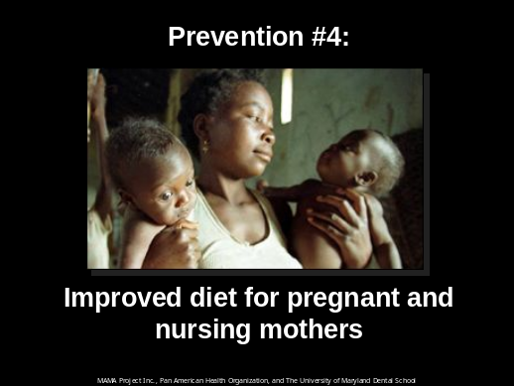 | Prevention #4: Improved diet for pregnant and nursing mothers  Pregnant and nursing mothers need to eat a healthy, balanced diet to ensure good health from themselves and their children. Maternal short stature and iron deficiency anemia contribute to at least 20% of maternal deaths. In addition, maternal undernutrition increases the chances of low birth weight, which then increases the probability of neonatal deaths due to infection.¹  ¹World Health Organization. Countdown to 2015 Decade Report
Slide 44 | 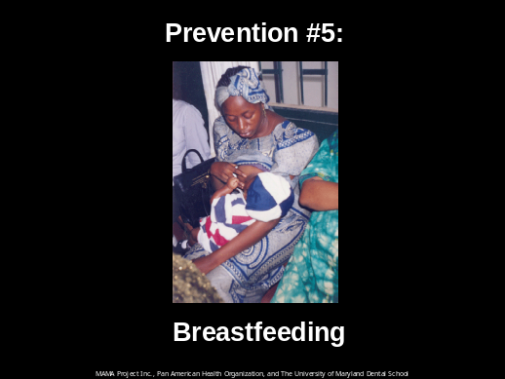 | Prevention #5: Breastfeeding  Breastfeeding plays an integral role in the survival and development of a child and also improves the well-being of the mother.
Slide 45 | 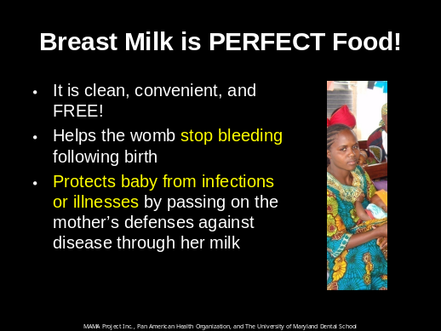 | Breast Milk is PERFECT Food  (Read Slide)
Slide 46 | 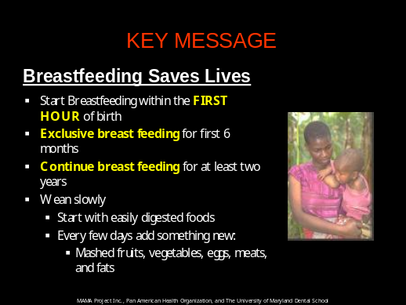 | KEY MESSAGE: Breastfeeding Saves Lives  (Read Slide)  One of the biggest mistakes that caregivers make is to give infants sugar water or tea starting at birth. This deprives babies of the best antibody-rich breast milk that mothers produce right after delivery.
Slide 47 | 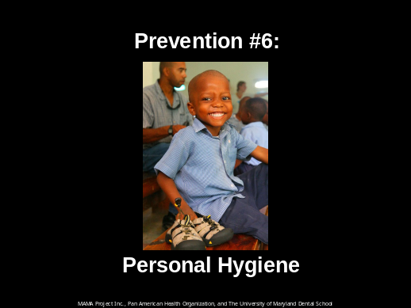 | Prevention #6: Personal Hygiene  Staying clean is of great importance in the prevention of many kinds of infections.
Slide 48 |  | Oral Hygiene  A main component of personal hygiene is oral hygiene.  (Read Slide)
Slide 49 | 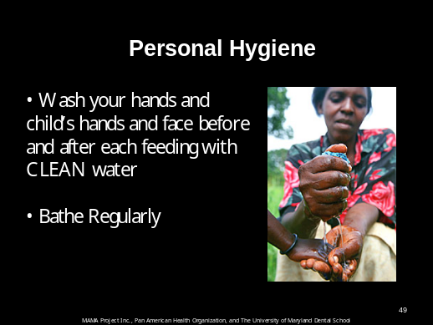 | Personal Hygiene  Many common infections are spread from person to person simply because people fail to wash their hands with clean water and consequently transmit dangerous germs to one another.
Slide 50 | 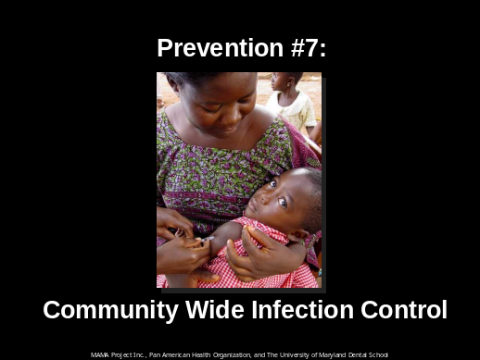 | Prevention #7 Community Wide Infection Control  Community wide infection control includes three main interventions  - Immunizations  - Deworming  - Insecticide Treated Bed Nets
Slide 51 | 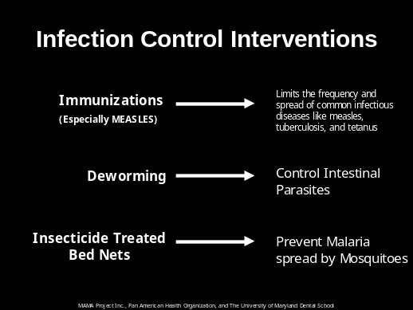 | Infection Control Interventions  (Read Slide)
Slide 52 | 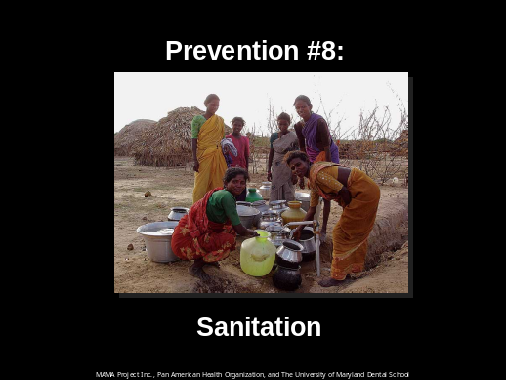 | Prevention #8: Sanitation
Slide 53 | 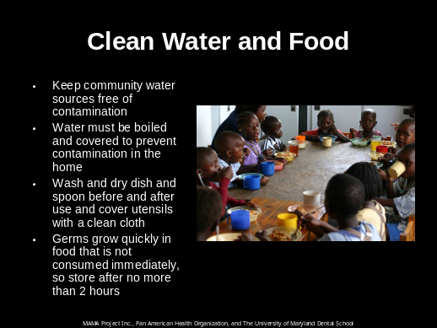 | Clean Water and Food  (Read Slide)  Be vigilant to keep rivers and streams clean upstream from any place where drinking water is taken.
Slide 54 | 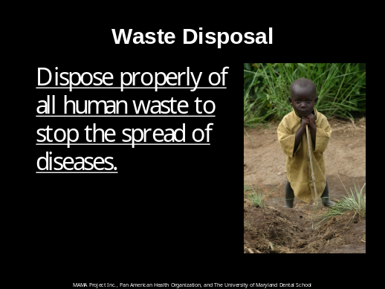 | Waste Disposal  It is important not to defecate or throw garbage near any water source.
Slide 55 | 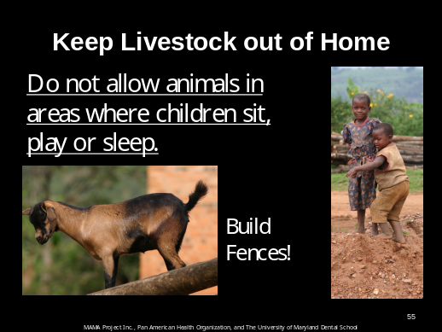 | Keep Livestock out of Home  In order to prevent the spread of infectious diseases, it is very important that pigs and other livestock do not come into the house or places where children play.
Slide 56 | 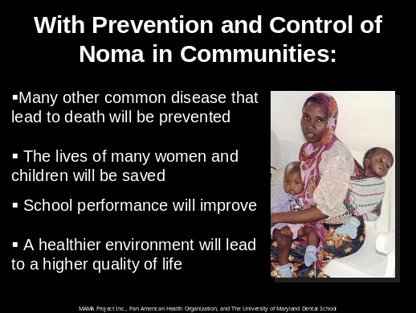 | With Prevention and Control of Noma in Communities:  (Read Slide)

Discussion:

- Now that you have been introduced to the disease of noma, have any of you seen early warning signs of noma in the community?

- Ask for repetition of Key Messages

- What prevention strategies can you promote in your communities?

